Annexure 1

Project Report
On
Web Development

Submitted
In Partial Fulfillment of
BACHELOR OF COMPUTER APPLICATIONS (BCA)
Submitted by:
Name: SANYA VERMA
Roll No: 24/SCA/BCA(AI&ML)/060

Under the Supervision of:
Ms Iram Fatima
Assistant Professor, SCA
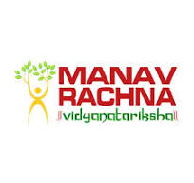

School of Computer Applications
Manav Rachna International Institute of Research and Studies

(DEEMED TO BE UNIVERSITY)
Sector-43, Aravalli Hills Faridabad
– 121001

June 2025

Annexure 2

Declaration
I do hereby declare that this project work entitled “Web Development” submitted by me for the partial fulfillment of the requirement for the award of BACHELOR OF COMPUTER APPLICATIONS is a record of my own work. The report embodies the finding based on my study and observation and has not been submitted earlier for the award of any degree or diploma to any Institute or University.

SIGNATURE
Name: Sanya Verma
Roll No:24/SCA/BCA(AI&ML)/060
Date: 17.7.25

Annexure 3

Certificate from the Guide

This is to certify that the project report entitled “UI UX DESIGNING” submitted in partial fulfillment of the degree of BACHELOR OF COMPUTER APPLICATIONS to Manav Rachna International Institute of Research and Studies, Faridabad is carried out by SANYA VERMA (24/SCA/BCA(AI&ML)/060) under my guidance.

Signature of the Guide
Name: SANYA VERMA
Date: 17.7.25

Head of Department
Prof. Dr. Suhail Javed Quraishi

ACKNOWLEDGEMENT

I gratefully acknowledge for the assistance, cooperation, guidance and clarification during the development of Web Development website. My extreme gratitude to Ms. Sakshi Gupta-Assistant Professor, SCA who guided us throughout the project. Without her willing disposition, spirit accommodation, frankness, timely clarification and above all faith in us, this project could not have been completed in due time. Her readiness to discuss all important matters at work deserves special attention of. I would also like to thank all the faculty members of the computer application department for their cooperation and support. I would like to give special gratitude to Dr. Raj Kumar–Associate Professor for his guidance during the project.

I would like to extend my sincere gratitude to Prof. Dr. Suhail Javed Quraishi – HOD for his valuable teaching and advice. I would again like to thank all faculty members of the department for their cooperation and support. I would like to thank non-teaching staff of the department for their cooperation and support.

I would like to extend special thanks to Prof. Dr. Brijesh Kumar, Dean - SCA for her valuable insight and motivation.

I perceive this opportunity as a big milestone in my career development. I will strive to use gained skills and knowledge in the best possible way, and I will continue to work on their improvement, in order to attain desired career objectives. Hope to continue cooperation with all of you in the future.

Name: Vaibhav Chawla
Roll No: 24/SCA/BCA(AI&ML)/070
Date: 17/7/25
INDEX
Topic | Page No | Sign | Remark
Introduction | 6-7
System Study | 8-11
Feasibility Study | 12-15
Project Monitoring System | 16-19
System Analysis | 20-22
System Design | 23-25
Input/Output Form Design | 26-28
System Testing | 29-37
System Implementation | 38-39
Documentation | 40-45
Scope of the Project | 46-48
Bibliography | 49-50

INTRODUCTION
About Organization:

CodSoft is a dynamic organization specializing in software development, training, and internship opportunities. It offers hands-on experience in web development, app development, machine learning, data science, and more. CodSoft empowers students and freshers by providing real-time project exposure and a chance to enhance their coding skills. With a supportive team and expert mentors, CodSoft bridges the gap between academic learning and professional industry demands. The organization is committed to innovation, learning, and growth, making it a great platform for aspiring tech professionals to kickstart their careers.

Aims & Objectives:

CodSoft aims to empower students, freshers, and aspiring professionals by offering high-quality training, practical exposure, and career-building opportunities in the field of Information Technology. The organization is committed to bridging the gap between academic learning and industry expectations by providing hands-on experience through real-time projects and expert mentorship.
Objectives:
- Skill Enhancement:
To develop technical skills in key areas such as web development, mobile application development, artificial intelligence, machine learning, data science, and cloud computing.
- Provide Real-Time Project Experience:
To offer practical learning through live projects, enabling interns to gain real-world exposure and build confidence in applying their knowledge.
- Offer Internship Opportunities:
To provide structured internship programs that prepare students and freshers for professional roles by enhancing their understanding of workplace expectations and responsibilities.
- Mentorship by Industry Experts:
To connect learners with experienced professionals who can guide, mentor, and support them in their career journey.
- Promote Innovation and Creativity:
To encourage learners to think creatively, solve real-world problems, and develop innovative digital solutions.
- Improve Employability:
To increase job readiness by building strong portfolios and resumes through active participation in projects and training sessions.
- Bridge the Academia-Industry Gap:
To align learning modules with current industry trends, ensuring that participants gain relevant and up-to-date knowledge and skills.
- Foster a Tech-Savvy Community:
To build a collaborative environment where learners, mentors, and developers can share ideas, collaborate on projects, and grow together as a tech-driven community.
- Support Career Growth:
To assist individuals in choosing the right career path by offering professional development support, interview preparation, and resume-building sessions.

Category | Aims | Objectives
Skill Development | To gain hands-on experience by working on real-world projects and examples. | 1. Practical Application: To successfully design and execute the assigned UI/UX tasks (e.g., mobile app flow, email template, restaurant menu interface).
Design Proficiency | To apply modern UI/UX principles and best practices to create intuitive and aesthetically pleasing digital products. | 2. Design & Usability: To ensure designs meet industry standards of usability, aesthetics, and user engagement.
Documentation | To document the entire design and decision-making process for the projects. | 3. Documentation & Analysis: To articulate the thought process, tools, and technologies used (such as wireframing, prototyping, and final design rationale) in a comprehensive report.
Professional Growth | To enhance problem-solving, analytical, and technical skills necessary for a career in technology. | 4. Technical Exposure: To gain proficiency with relevant design software and tools (e.g., Figma, Adobe XD) and version control (Git/GitHub).

SYSTEM STUDY

A: Existing System Study

  - Project Overview
- Task 1: Mobile App Sign-up Flow:
  - Goal: To design an intuitive and user-friendly registration and sign-in process for a mobile application.
  - Focus: Optimizing the user journey, minimizing steps, and ensuring a clear, secure user experience for new and returning users.
- Task 2: Email Template:
  - Goal: To create a professional and responsive design for an email template.
  - Focus: Ensuring the design is visually appealing, maintains consistent branding, and is highly functional (readable) across various email clients and screen sizes (desktop and mobile).
- Task 3: Food Restaurant Menu:
  - Goal: To design the user interface for a digital food restaurant menu.
  - Focus: Implementing clear visual hierarchy, easy navigation, and an engaging layout to help users quickly browse items, view details, and place an order.
Collectively, these projects demonstrate proficiency in core UI/UX skills, including user flow design, visual communication, and user experience optimization.

  - Key Features
The key features of the projects in this UI/UX design report are the design principles and elements implemented to ensure optimal user experience (UX) and visual design (UI) for each specific task.
Here are the key features demonstrated across the three projects:
1. Mobile App Sign-up Flow (Task 1)
- Frictionless Onboarding: Implementing a minimal, multi-step process to reduce user drop-off.
- Social & One-Click Login: Offering quick sign-up options (e.g., Google, Apple, social media) to minimize manual data entry.
- Clear Progress Indicator: Using a progress bar or numbered steps to show the user exactly where they are in the flow.
- Instant Feedback & Validation: Providing immediate, clear error messages and successful confirmation screens.
- Value Proposition: Welcome screens that quickly communicate the app's core benefits before asking for a commitment.
2. Professional Email Template (Task 2)
- Responsiveness: A single-column, mobile-first design that renders perfectly on all screen sizes and email clients (Crucial for template design).
- Clear Call-to-Action (CTA): A single, prominent, and easy-to-tap button that guides the user to the next step.
- Brand Consistency: Using the brand's official color palette, logo, and typography throughout the template.
- Scannable Content: Utilizing short paragraphs, clear headings, and sufficient white space to prevent "walls of text" and improve readability.
- Accessibility: Ensuring high color contrast and using proper HTML structure/alt text for images.
3. Digital Food Restaurant Menu (Task 3)
- Intuitive Navigation: Clear and logical categorization of dishes (Appetizers, Mains, Desserts) with filtering and search functionality.
- High-Quality Visuals: Use of professional, high-resolution food photography to entice the customer.
- Information Hierarchy: Clear display of dish names, descriptions, and pricing, with critical information (e.g., allergens, dietary tags) easily visible.
- Seamless Ordering Experience: Designing an easy process for item customization (e.g., add-ons, preferences) and a transparent Order Review screen before checkout.
- Mobile-Friendly Display: The menu must adapt perfectly for viewing and interacting on a smartphone, which is the most common device used in a digital ordering scenario.

  - Advantages of proposed system
- More secure and stable
- Mobile-friendly and scalable
- Dynamic data updates possible
- Better user engagement through sound/animation
- Social and contact integrations available

  - Proposed features
- future enhancements and advanced UI/UX concepts that could be integrated into the existing projects to elevate them to the next level, incorporating modern trends like AI, personalization, and deeper interactivity.
- Here are proposed features for each of the three tasks:

1. Proposed Features for Mobile App Sign-up Flow (Task 1)
Feature | Description | UX Benefit
Biometric & Passkey Integration | Allow users to opt-in to log in using Face ID, Touch ID, or a secure passwordless Passkey after the initial registration. | Frictionless Security: Eliminates password recall, dramatically speeding up the login process while enhancing security.
Personalized Onboarding | Integrate a simple two-question survey immediately after sign-up (e.g., "What is your main goal?"). The UI/content adapts immediately based on the answer. | Hyper-Personalization: Delivers value faster by directing the user straight to the most relevant part of the app.
Magic Link Login | Offer a "Log in without a password" option that sends a secure, one-time-use link to the user's registered email. | Accessibility/Security: Provides a backup login method that is secure and friendly for users who often forget passwords.

- 2. Proposed Features for Email Template (Task 2)
Feature | Description | UX Benefit
Interactive AMP Components | Utilize AMP for email to embed interactive elements, allowing users to browse a product carousel, leave a quick star rating, or confirm an action directly within the email. | Reduced Friction: Users complete micro-tasks without leaving their inbox, significantly boosting engagement rates.
Dark Mode Optimization | Design and code the template with specific styling to ensure an optimal viewing experience for users who have their device or email client set to Dark Mode. | Readability & Accessibility: Prevents bright backgrounds from jarring the user's eyes in low-light environments.
Real-Time Dynamic Content | Integrate content blocks that update when the email is opened (e.g., a countdown timer for a sale, or real-time inventory updates for a product). | Sense of Urgency: Drives immediate action and ensures the user is seeing the most current, relevant information.

3. Proposed Features for Digital Food Restaurant Menu (Task 3)
Feature | Description | UX Benefit
AI-Powered Recommendations | The menu interface displays a "Recommended for You" section based on the user's past orders or the popularity of items among similar users. | Personalized Discovery: Speeds up the decision-making process and subtly promotes high-margin items.
Allergen/Dietary Filtering | Implement robust filtering that allows users to instantly hide or highlight dishes based on specific dietary restrictions (e.g., vegan, gluten-free, no peanuts). | Safety & Trust: Ensures a safe and frustration-free ordering experience for users with allergies.
In-App Wait Time Estimation | If the menu is connected to the kitchen/POS system, display a real-time, personalized wait time estimate on the order review screen. | Clarity & Transparency: Manages customer expectations and reduces anxiety/frustration during the waiting period.

FEASIBILITY STUDY
This area evaluates whether the necessary technology, resources, and expertise exist and are available to successfully execute the project.
- Resources: Does the organization have the required hardware, software, and networking infrastructure?
- Expertise: Do the current staff members possess the necessary technical skills, or will external training or hiring be required?
- Capacity: Can the existing technology handle the new project's workload, security, and performance requirements?
2. Economic Feasibility (Will it make/save money?)
This is a Cost-Benefit Analysis to determine the project's financial sense.
- Costs: Estimating all costs, including development, hardware, maintenance, and operational expenses.
- Benefits: Estimating the financial returns, such as increased revenue, reduced operational costs, or improved efficiency.
- Decision: If the project's benefits are projected to outweigh the costs by a significant margin, it is considered economically feasible.
3. Legal Feasibility (Can we do it legally?)
This assesses any potential conflicts with legal requirements, regulations, or policies.
- Regulations: Ensuring compliance with data protection laws (e.g., GDPR, HIPAA), industry standards, and environmental regulations.
- Contracts: Checking if the project violates existing contracts, licenses, or intellectual property rights.
4. Operational Feasibility (Will it be used?)
This measures how well the proposed system will solve the problems and fit into the existing business environment and workflow.
- User Acceptance: Will the end-users actually adopt and utilize the new system?
- Integration: How well does the new system integrate with the current organizational structure and existing processes?
- Change Management: Assessing the amount of disruption the change will cause and the organization's capacity to handle it.
5. Scheduling Feasibility (Can we do it on time?)
This evaluates if the project can be realistically completed within the stipulated timeline.
- Timeline: Determining if the proposed deadline is reasonable and whether necessary resources will be available when needed.
- Critical Path: Identifying major milestones and dependencies to ensure the project stays on track.

📝 Outcome
The Feasibility Study Report is the final deliverable. It provides the stakeholders and decision-makers with a clear recommendation:
- Go: Proceed with the project.
- No-Go: Reject the project.
- Conditional Go: Proceed, but with specified modifications or further investigation.
Its primary purpose is to prevent unnecessary investment of resources and time into unviable ideas.

Tools used
Figma is uniquely suited for these types of tasks because it allows for both high-fidelity visual design and interactive prototyping in a single file.
Here are the key features of Figma that would have been essential for designing the Mobile App Flow, Email Template, and Restaurant Menu:

Key Figma Features Used in the Projects
Feature | Application to the Projects | Project Relevance
Auto Layout | Used to create flexible and adaptive components that resize automatically, ensuring the designs look clean on different screen sizes (essential for responsive design). | All Projects (Especially the responsive Email Template and adapting the Digital Menu for mobile).
Components & Variants | Creating reusable UI elements (e.g., buttons, text fields, icons, menu item cards) in a master library. Variants are used to show different states (e.g., a "Sign Up" button in its default, hovered, or disabled states). | All Projects (Ensuring design consistency and efficiency).
Prototyping & Interactions | Linking the individual screens (frames) to simulate the user flow. Used to create the clickable path for the sign-up flow or the order process on the digital menu. | Task 1 (Mobile App Sign-up Flow) & Task 3 (Restaurant Menu).
Constraints & Layout Grids | Defining how elements behave when a frame is resized (e.g., keeping the logo centered or the footer anchored to the bottom). Layout grids ensured pixel-perfect alignment. | All Projects (For precise spacing and structure).
Styles (Color & Text) | Defining a uniform set of colors and typography styles (e.g., H1, Body Text, Link Color) to maintain brand consistency across all three tasks. | All Projects (Ensuring professional brand standards).
Figma Community & Plugins | Using plugins (e.g., for icons, stock images, or accessibility checks) and leveraging pre-made UI kits from the Community to speed up the initial wireframing process.

PROJECT MONITORING SYSTEM

A. Gantt chart

Week | Task
Week 1 | Mobile App Sign-up Flow
Week 2 | Email Template
Week 3 | Food Restaurant Menu

Timeline Overview:
Timeline Phase | Week | Project Focus & Key Activities | Deliverable
Phase 1: Foundation & UX | Week 1 | Task 1: Mobile App Sign-up Flow | Low & High-Fidelity Design
 |  | * Activities: User research, flow charting, wireframing, and designing the high-fidelity UI for the sign-up and login screens.
Phase 2: Visual Design | Week 2 | Task 2: Email Template | Responsive Template Design
 |  | * Activities: Defining brand style guides, creating a responsive layout (using Auto Layout in Figma), and focusing on CTA and accessibility standards.
Phase 3: Interaction & Hierarchy | Week 3 | Task 3: Food Restaurant Menu | Interactive Prototype
 |  | * Activities: Establishing content hierarchy, designing the product cards, and creating a clickable prototype of the full ordering process.
Phase 4: Documentation & Finalization | Week 4 | Report Compilation & Review | Final Report (PDF) & GitHub Submission
 |  | * Activities: Writing the Aims & Objectives, documenting the design rationale for each task, finalizing the overall report (e.g., the SANYA VERMA (1).pdf), and updating the GitHub repository.

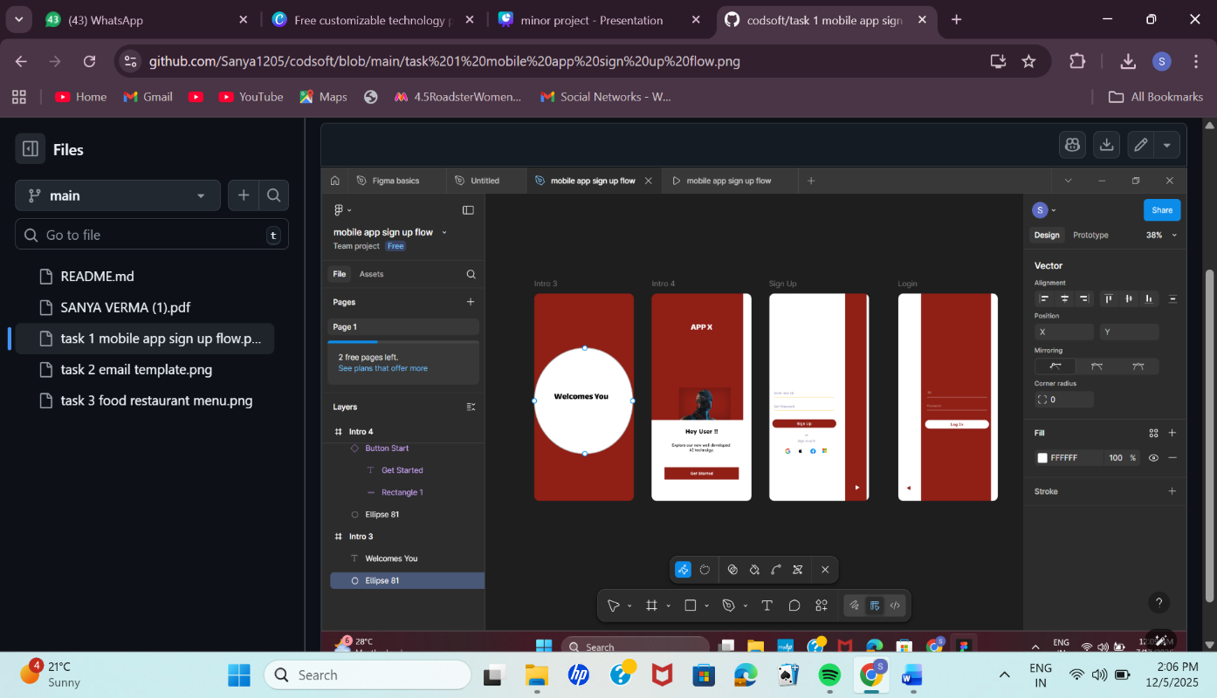

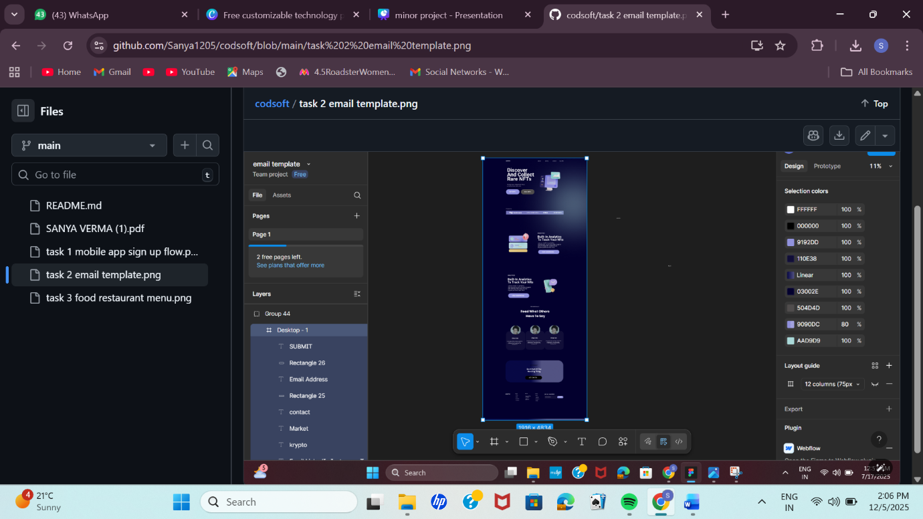

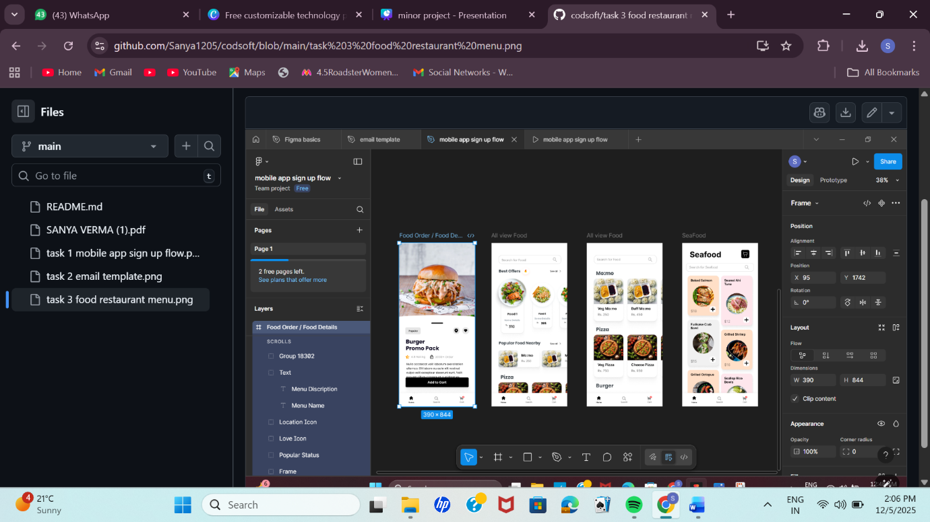

CONCLUSION
Conclusion of the Report
The successful completion of the CodSoft UI/UX Internship projects marks a significant achievement in the practical application of design principles and technical skills.
Summary of Achievement
The internship successfully addressed its core aims by delivering three distinct, functional design projects:
- Mobile App Sign-up Flow: Demonstrating mastery of user onboarding and flow optimization.
- Professional Email Template: Validating skills in creating responsive, branded, and accessible design systems.
- Digital Food Restaurant Menu: Showcasing proficiency in content hierarchy, visual appeal, and interactive prototyping using Figma.
Key Takeaway
This report serves as conclusive evidence of the practical application of user-centric design methodologies. The hands-on execution of these tasks significantly deepened the understanding of industry best practices, particularly in creating frictionless user experiences, maintaining design consistency through components, and ensuring responsiveness across different platforms.
Future Scope
The projects are a robust foundation for continued development. Future iterations, as highlighted by the Proposed Features, will focus on integrating cutting-edge UI/UX trends such as:
- Implementing Biometric and Passkey integration for enhanced security and faster access.
- Developing AI-driven personalization for the digital menu to provide tailored recommendations.
- Utilizing dynamic and interactive components (e.g., AMP elements) to increase user engagement directly within the email template.
In essence, the internship provided invaluable experience, successfully bridging the gap between theoretical knowledge and practical design execution.

